**Practical No. 5**

1. **Working with Check Boxes and Radio Button.**
2. **Check Boxes**

**Designing UI**

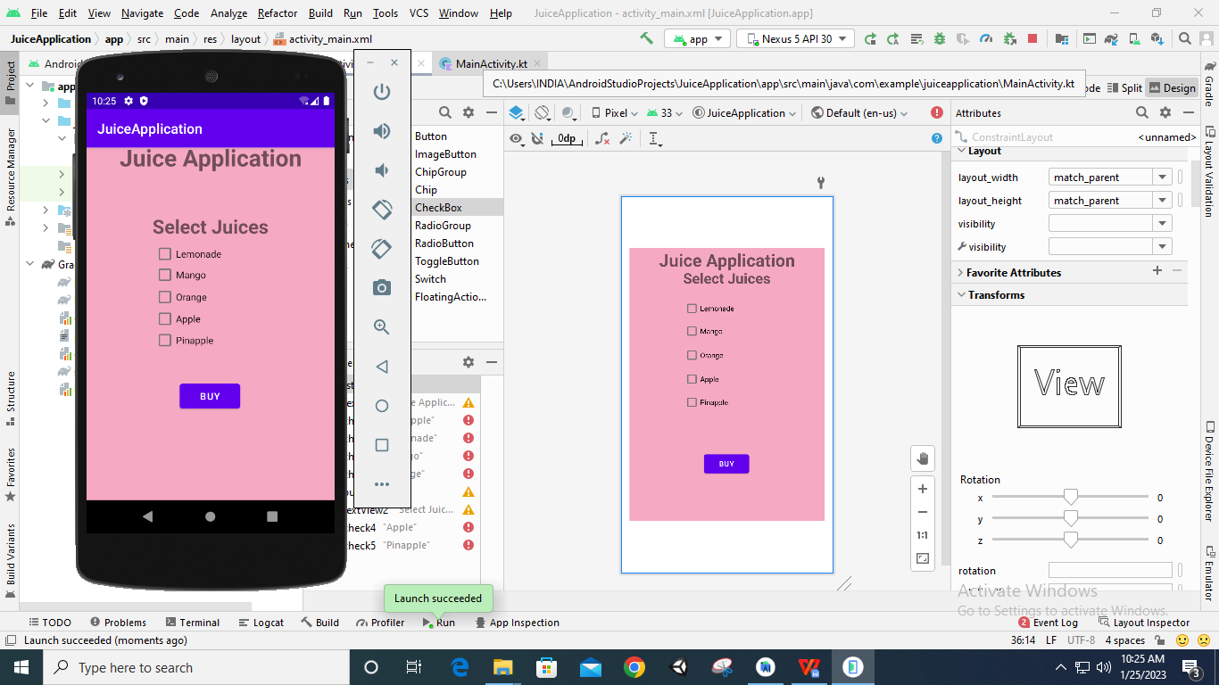

**Code:**

**package** com.example.juiceapplication  
  
**import** androidx.appcompat.app.AppCompatActivity  
**import** android.os.Bundle  
**import** android.widget.Button  
**import** android.widget.CheckBox  
**import** android.widget.Toast  
  
**class** MainActivity : AppCompatActivity() {  
 **override fun** onCreate(savedInstanceState: Bundle?) {  
 **super**.onCreate(savedInstanceState)  
 setContentView(R.layout.*activity_main*)  
  
 **var** c1: CheckBox =findViewById(R.id.*check1*)  
 **var** c2: CheckBox =findViewById(R.id.*check2*)  
 **var** c3: CheckBox =findViewById(R.id.*check3*)  
 **var** c4: CheckBox =findViewById(R.id.*check4*)  
 **var** c5: CheckBox =findViewById(R.id.*check5*)  
  
 **var** totalAmount: Int = 0  
  
 **var** btn: Button =findViewById(R.id.*button*)  
 btn.setOnClickListener()**{  
 var** builder:StringBuilder=StringBuilder()  
 **if**(c1.*isChecked*){  
 builder.append(**" "**+c1.*text*)  
 totalAmount += 20  
 }  
 **if**(c2.*isChecked*){  
 builder.append(**" "**+c2.*text*)  
 totalAmount += 90  
 }  
 **if**(c3.*isChecked*){  
 builder.append(**" "**+c3.*text*)  
 totalAmount += 80  
 }  
 **if**(c4.*isChecked*){  
 builder.append(**" "**+c4.*text*)  
 totalAmount += 50  
 }  
 **if**(c5.*isChecked*){  
 builder.append(**" "**+c5.*text*)  
 totalAmount += 70  
 }  
 Toast.makeText(*applicationContext*,**"You have selected "**+builder,Toast.*LENGTH_LONG*).show()  
 Toast.makeText(*applicationContext*,**"Your Total: "**+totalAmount+**"Rs"**,Toast.*LENGTH_LONG*).show()  
 **}** }  
}

**Output:**



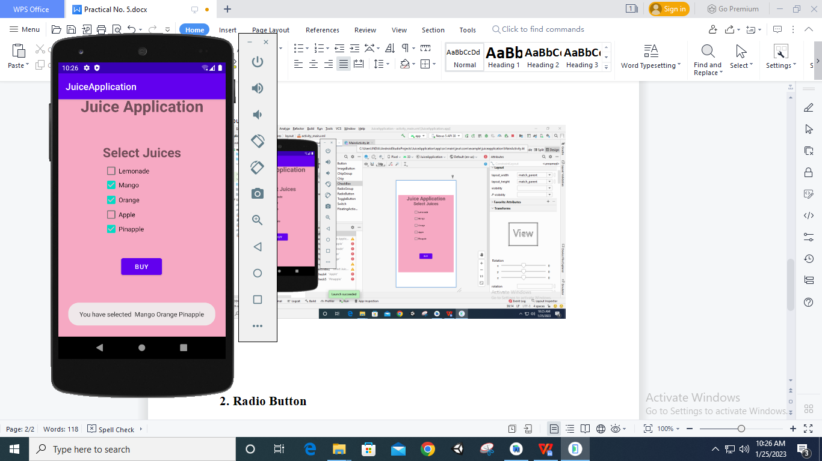

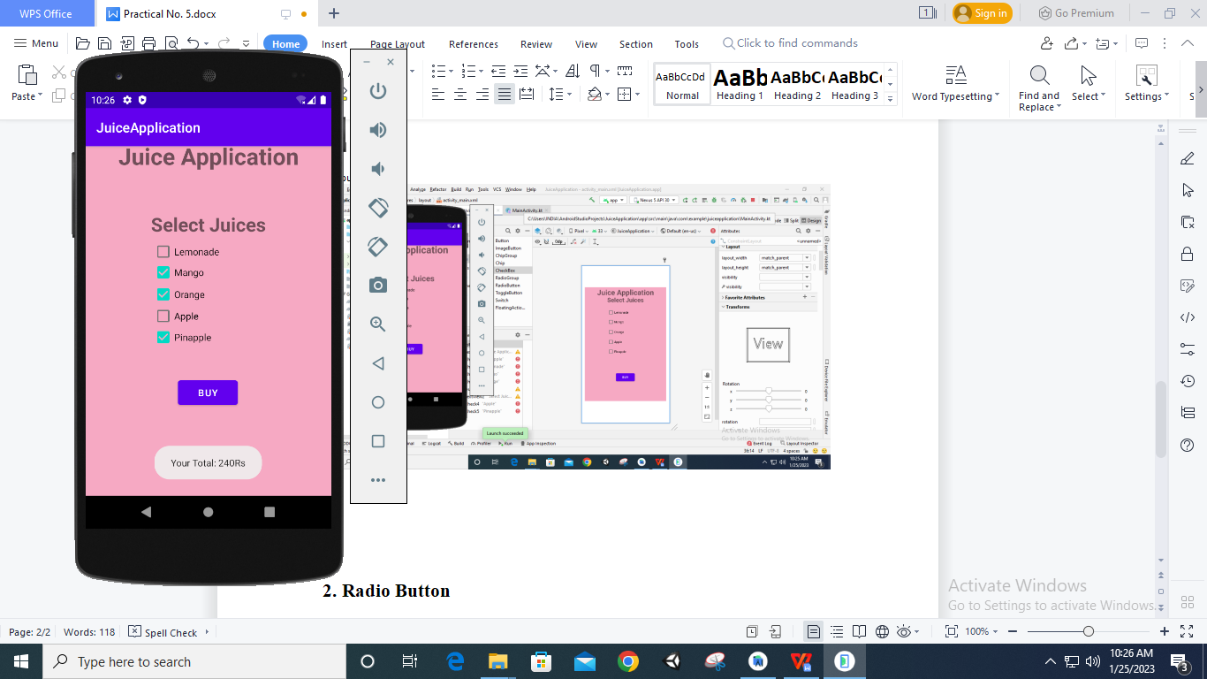

1. **Radio Button**

**Designing UI**

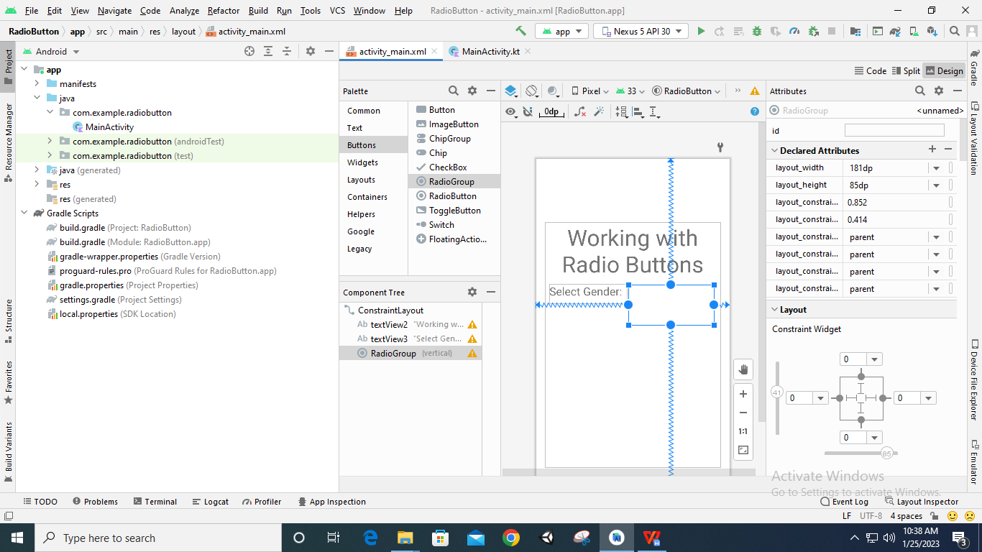

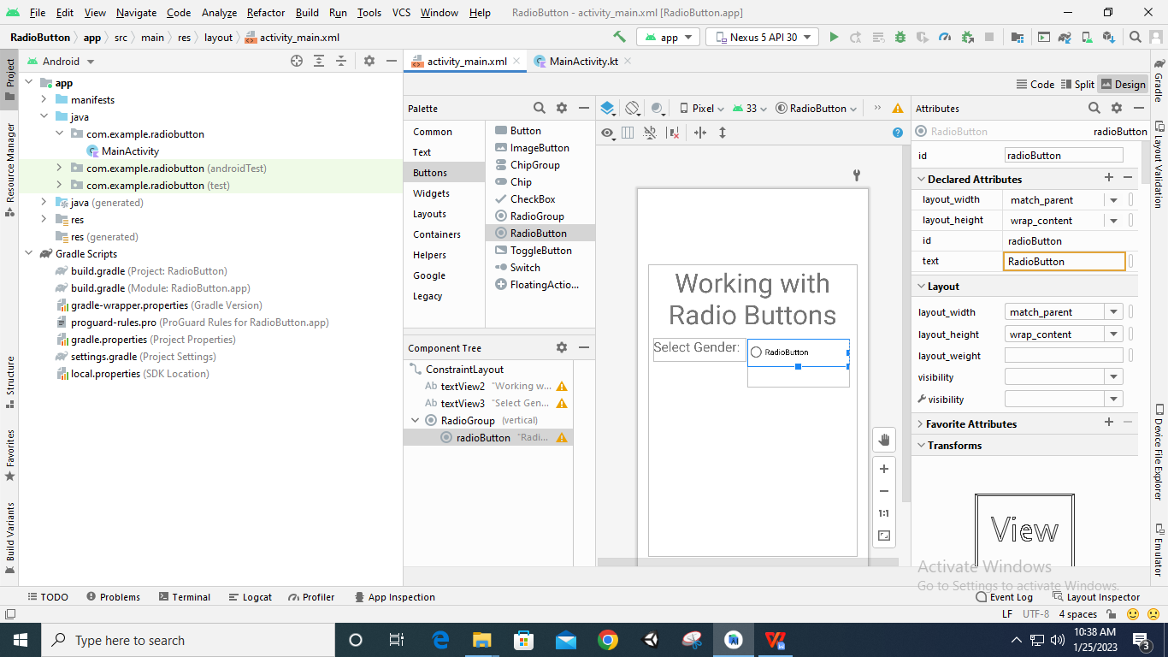

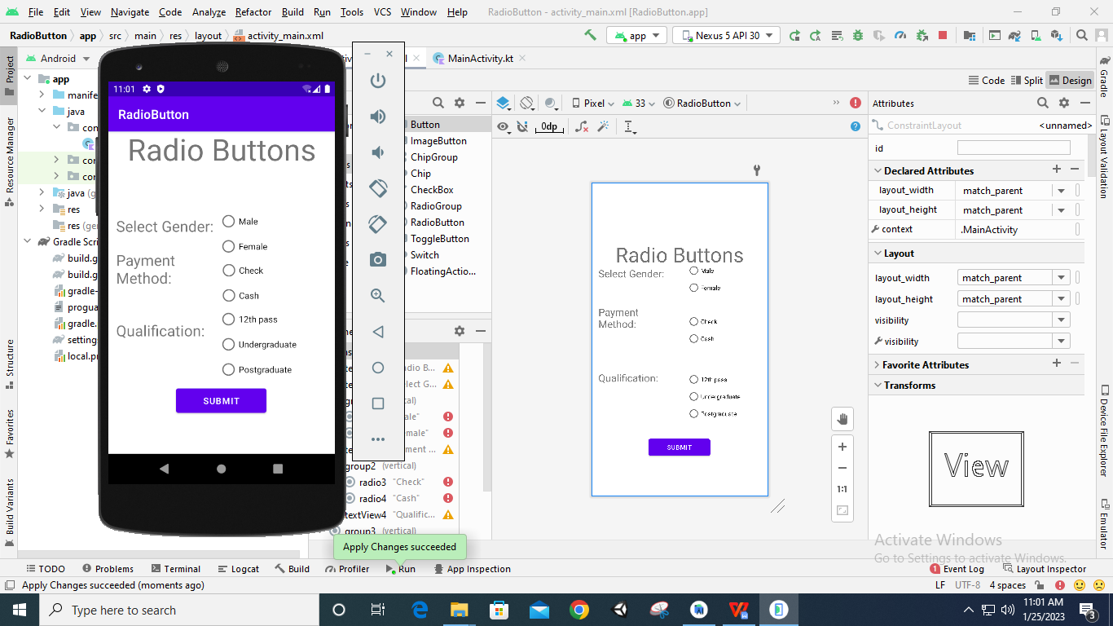

**Code:**

**package** com.example.radiobutton  
  
**import** androidx.appcompat.app.AppCompatActivity  
**import** android.os.Bundle  
**import** android.widget.Button  
**import** android.widget.RadioButton  
**import** android.widget.RadioGroup  
**import** android.widget.Toast  
  
**class** MainActivity : AppCompatActivity() {  
 **override fun** onCreate(savedInstanceState: Bundle?) {  
 **super**.onCreate(savedInstanceState)  
 setContentView(R.layout.*activity_main*)  
  
 **var** group1: RadioGroup =findViewById((R.id.*group1*))  
 **var** group2: RadioGroup =findViewById((R.id.*group2*))  
 **var** group3: RadioGroup =findViewById((R.id.*group3*))  
  
 **var** btn: Button =findViewById(R.id.*button*)  
 btn.setOnClickListener()**{  
 var** id1:Int=group1.*checkedRadioButtonId* **var** id2:Int=group2.*checkedRadioButtonId* **var** id3:Int=group3.*checkedRadioButtonId* **var** group1rb: RadioButton =findViewById(id1)  
 **var** group2rb: RadioButton =findViewById(id2)  
 **var** group3rb: RadioButton =findViewById(id3)  
  
 Toast.makeText(*applicationContext*,**"Your Gender is "**+group1rb.*text*+**",\nYour Payment mode is "**+group2rb.*text*+**"\nand Your Qualification is "**+group3rb.*text*,Toast.*LENGTH_LONG*).show()  
 **}** }  
}

**Output:**

